Leaky Toilets Equates to Money Down the Drain

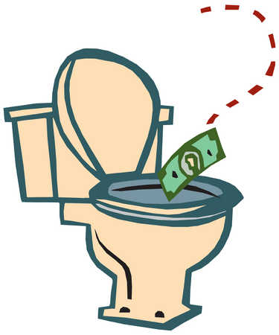
One of the most costly household wastes of water is a leaky toilet. According to the American Water Works Association, toilets account for 27 percent of all indoor water use in a typical residence. The amount of water used by toilets is only increased when there is a leak. It is estimated that 20 percent of all toilets leak. Toilet leaking results in a tremendous amount of water loss. Every day that a silent leak goes undetected can amount to as much as 300 gallons of water. That is three times the amount of water the average American uses in an entire day. When water is wasted, that easily translates to money spent on higher water bills. Depending on the size of the leak, it is possible to end up paying an extra $500.00 every year on water that was never used. Performing a leak test regularly allows you to take action before more water, and ultimately money, can be wasted.

What causes toilet leaking?
When you hear the sound of water coming from your toilet long after flushing, or your toilet seems to flush by itself for no apparent reason, you could have a leak. Read more to learn about a toilet’s major culprits.

Flush Valve Problems | Fill Valve Problems
Most toilet leaks are caused by a faulty flush valve, or "tank flapper". To maintain a watertight seal, a flapper valve should be replaced every 3 to 5 years. Some leaks can be heard by the sound of running water but some leaks are silent and often go undetected.  To discover a silent leak, put dye tablets or food coloring in the tank. Do not flush. If, after a half hour, colored water appears in the bowl, you have a leak. | The second most frequent cause of a leaking toilet tank is a broken or inadequately placed fill valve. Problems occur when the shut-off valve does not completely close or the float is placed too high. If this happens, the tank will experience a continuous flow of water, which then enters the overflow tube. Leaks involving the fill valve are not as easily detected.  Once the toilet tank is full, remove the tank covering and check for water flowing in the overflow tube. If this is occurring, you have a leaking toilet tank on your hands.

